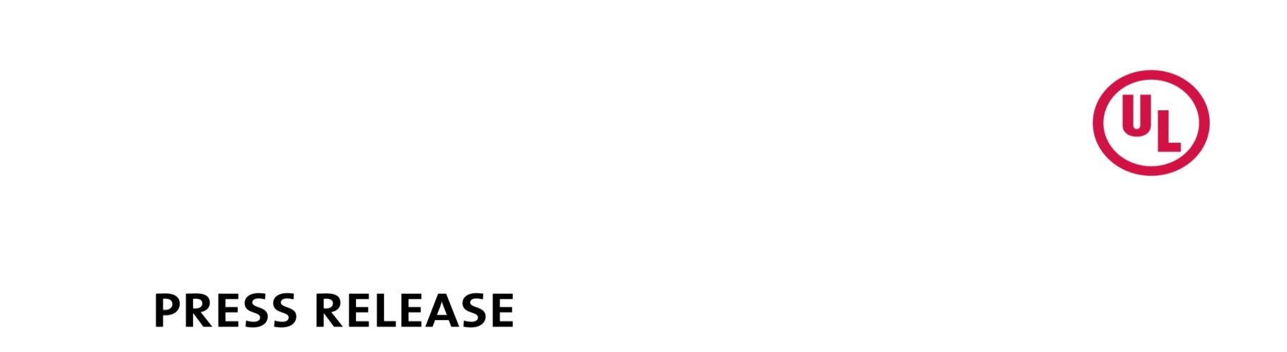

PUBLIC NOTICE

Peyton Zylke
Corporate Communications
UL
847.226.3483
Peyton.Zylke@ul.com

Release No. 22PN-07

UL Warns of Unauthorized UL Marks on Fire Extinguishers

NORTHBROOK, IL, (May 13, 2022) - The following is a notification from UL that the Starvvo fire extinguishers identified below bear unauthorized UL Certification Marks. UL has not evaluated these fire extinguishers to the appropriate Standards for Safety, and it is unknown if they comply with any safety requirements.

Name of Product: STARVVO Fire Extinguisher

Remedy: This product should be removed from service. UL recommends that users keep a UL Certified fire extinguisher in a readily accessible location to use in the event of a fire.

Identification on the Product:

The unauthorized UL Certification Mark appears on the extinguisher and the packaging.

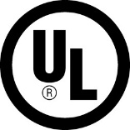

STARVVO
Fire Extinguisher

Photographs:

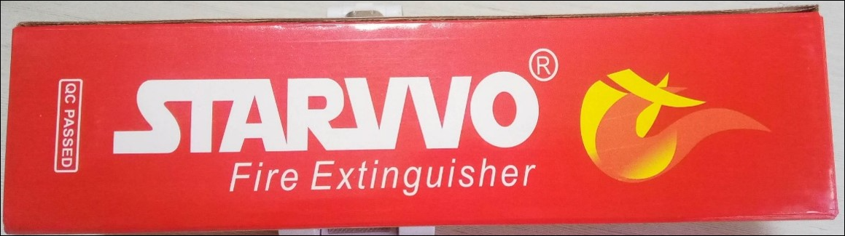

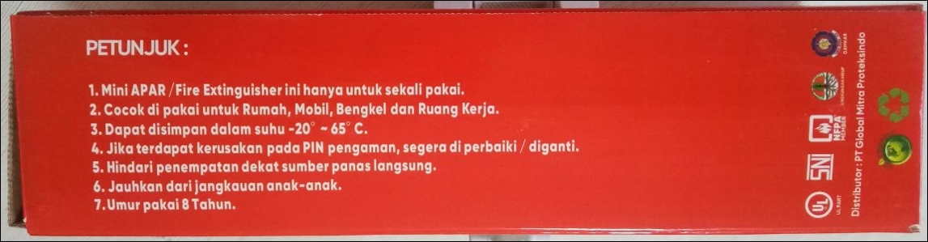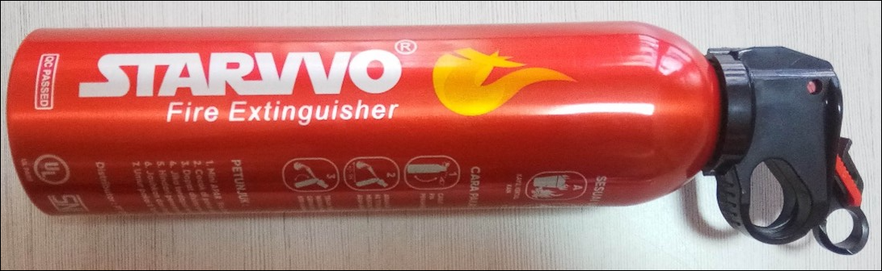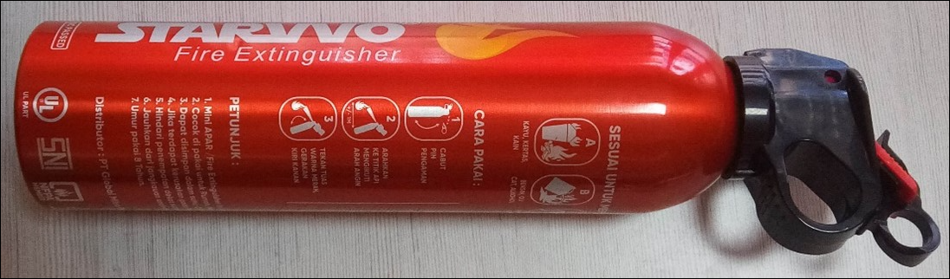

Known to be distributed and sold by: PT Global Mitra Proteksindo, PT Milenia Mega Mandiri, and other online sellers on eCommerce platforms. https://starvvo.com/produk-starvvo

About UL

UL is a global safety science leader. We deliver testing, inspection and certification (TIC), training and advisory services, risk management solutions, and essential business insights to help our customers, based in more than 100 countries, achieve their safety, security, and sustainability goals. We believe our deep knowledge of products and intelligence across supply chains make us the partner of choice for customers with complex challenges. Discover more at UL.com.

