PUBLIC NOTICE

Amy Patti
Communications Director
UL LLC
Amy.patti@ul.com
Release No. 21PN-26

UL Warns of Counterfeit UL Marks on SAFT Batteries (Release 21PN-26)

NORTHBROOK, Ill., (January 4, 2022) — The following is a notification from UL and SAFT that the SAFT Lithium/ Thionyl Chloride batteries identified below bear counterfeit UL Certification Marks. These batteries were not manufactured by SAFT and they have not been evaluated by UL to the appropriate Standards for Safety for the risk of fire, electric shock, or injury to persons. It is unknown if these batteries comply with any safety requirements.

SAFT is authorized to apply the UL Mark to model LS14500 batteries marked with date codes other than 17.228.98G. These batteries are not covered by this notice.

Name of Product: SAFT LS14500

Remedy: UL recommends that these products be immediately removed from service.

Identification on the Products:

The products bear counterfeit UL Recognized Component Marks and the following:

SAFT

LS14500

3.6V

Li-SOCl2

17.228.98G

Photos:

Photo 1
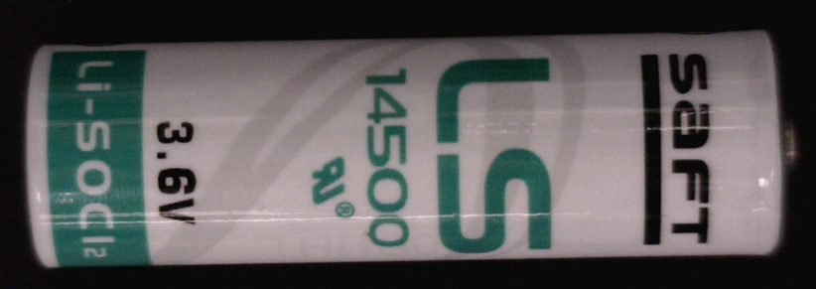

Photo 2

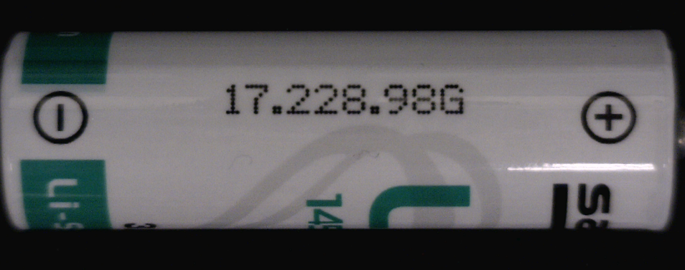

About UL
UL is the global safety science leader. We deliver testing, inspection and certification (TIC), training and advisory services, risk management solutions and essential business insights to help our customers, based in more than 100 countries, achieve their safety, security and sustainability goals. Our deep knowledge of products and intelligence across supply chains make us the partner of choice for customers with complex challenges. Discover more at UL.com.

For information about Standards development and other nonprofit activities, visit UL.org.

