DRAFT DRAFT DRAFT DRAFT DRAFT DRAFT DRAFT

PUBLIC NOTICE

Peyton Zylke
Corporate Communications
UL
847.226.3483
Peyton.Zylke@ul.com
Release No. 22PN-03

UL Warns of Unauthorized UL Marks and References to UL Certification for Smoke Hoods (Release 22PN-03)

NORTHBROOK, Ill., (March 15, 2022) - The following is a notification from UL that the packaging for the smoke hoods identified below bear unauthorized UL Certification Marks and references to UL Certification. These smoke hoods have not been evaluated by UL to the appropriate Safety Standards for Safety and it is unknown if the smoke hoods comply with any safety requirements.

Although the packaging for the smoke hoods bears TAIMIDE TECHNOLOGY INC’s UL Certification No. E231847 for plastics, these smoke hoods were not manufactured by TAIMIDE TECHNOLOGY INC, and the high temperature resistance certification claimed on the packaging is not issued by UL.

Name of Product: Smoke Hood or Pocket Smoke Mask

Remedy: UL recommends that you stop using this product.

Identification on the Packaging:

The packaging for the smoke hoods bears the following markings:

Fire Resistance 500°C
High Temperature Resistance Certification
(polyimide film of the smoke mask)
U.S.A. UL Standard
94 V-0 grade
NO: E231847

Or

Fire Resistance 450°C
Certificate of High temperature Resistance
UL Grade
(U.S.A.)
Passed the test of 94V-0 grade
UL NO:
E231847

Or

耐熱 500°C UP!
防火 UL合格!
頭罩耐高溫證明
UL等級
(美國)
94 V-0
NO.E231847

Photographs:

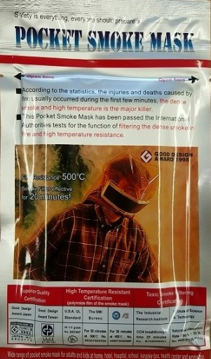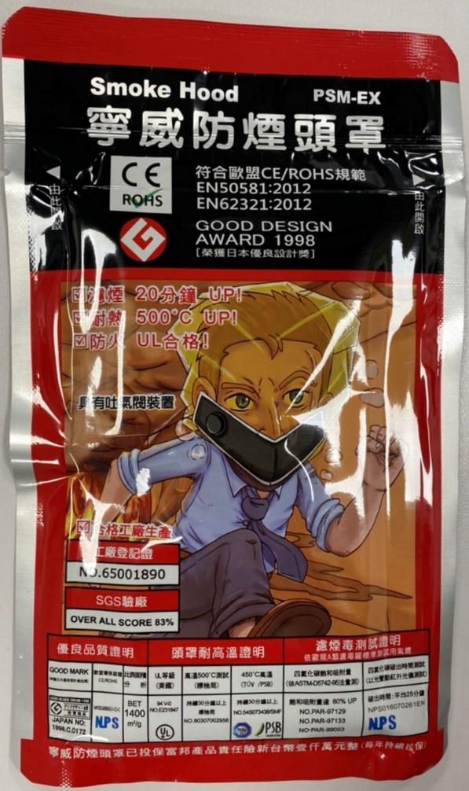

Known to be distributed and sold by: HKMASK Safety Ltd (www.hkmask.net), Niwei Scientific Enterprise Co Ltd (www.niwei.com.tw), and online retailers worldwide.

About UL

UL is the global safety science leader. We deliver testing, inspection and certification (TIC), training and advisory services, risk management solutions and essential business insights to help our customers, based in more than 100 countries, achieve their safety, security and sustainability goals. Our deep knowledge of products and intelligence across supply chains make us the partner of choice for customers with complex challenges. Discover more at UL.com.

For information about Standards development and other nonprofit activities, visit UL.org.

